

About Us ------- Services ------- Product & Solutions -------Industries ------Contact Us

**Managed Services ERP&POS**

**Consulting Services CRM**

**Digital Experience Analytics**

**Channel**

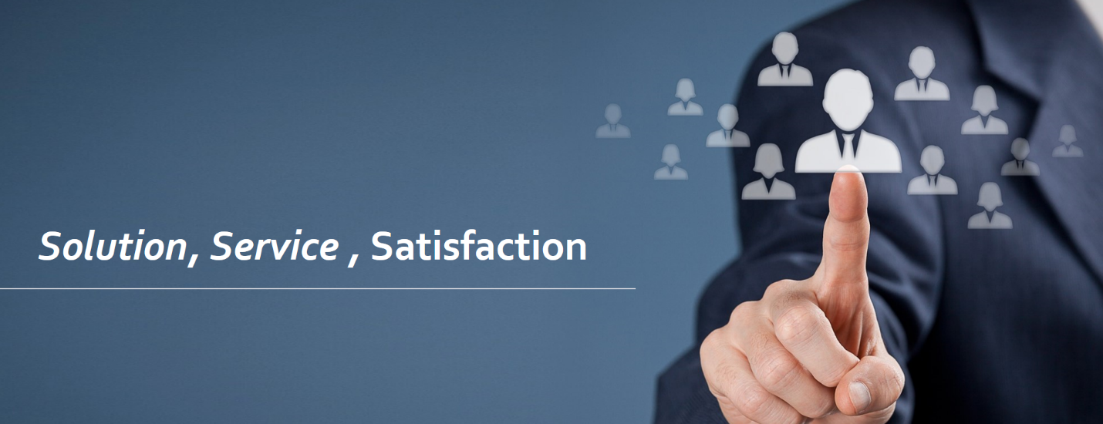

About Us

**Hashtag Technologies** is an IT company providing various specialized solutions & services across different verticals..

Established in 2018 , Hashtag Technologies has always focused on providing SaaS based software solutions that are designed specially for Small-to-Mid Enterprise. Since it’s beginning, Hashtag Technologies has focused on the needs of mainstream businesses and understands the unique requirements of small-to-medium-size businesses.

We believe that Technology will drive revolution going forward and business must invest in tech infrastructure and work towards improving their facilities. We assist our customers in choosing the business solutions covering horizontals like CRM, HRMS, Business Intelligence , ERP , Digital Solutions across verticals through our established network.

We help decision makers to revamp and recalibrate their business strategies and integrate artificial intelligence and machine learning. Our experts provide better collaboration between brand and consumer on data analytics as well, for quick decision making and gain consumer trust in a post-Covid world..

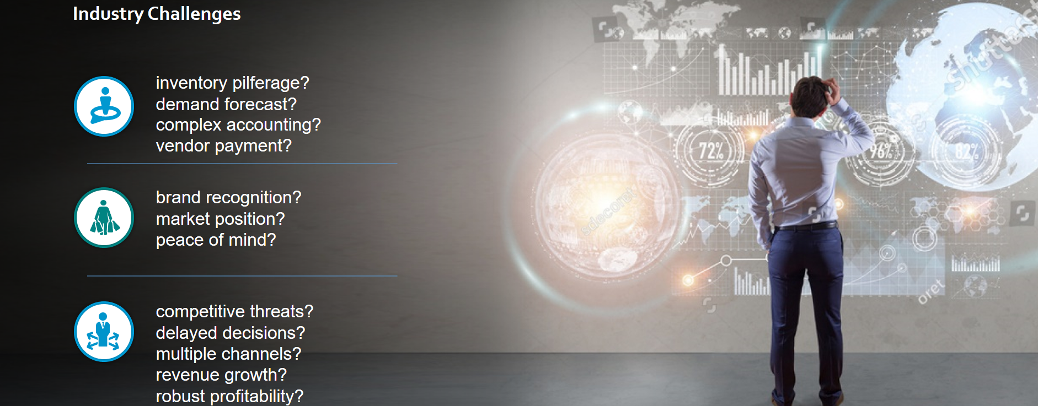

**How we can help you**

* Help identify pain areas and business processes that need attention
* Finds the Solution that best fits your budget and needs
* Reduces the risk of buying the wrong Business Software
* Easy Implementation for quick roll-out process.
* Ensure you get Affordable, Rightfitting & Reliable solutions tested over 100’s of businesses
* Trial before use with exact business scope mapping.
* Reduce upfront investment and Monthly Maintenance cost reduced as well.
* We suggest SaaS offerings that are easy to use since they already come with baked-in best practices and samples.
* The costs and effort associated with upgrades and new releases are lower than the traditional model that usually forces you to buy an upgrade package and install it.
* Compared with the traditional model, you don't have to buy another server or software. You only need to enable a new SaaS offering and, in terms of server capacity planning, the SaaS provider will own that.

**What we believe**

Passion is a choice not a chance.

Industries

* Retail
* Manufacturing
* Distribution
* Healthcare
* Hospitality
* Automobile
* Education
* Restaurants
* Travel & Tourism
* Media & Entertainment

Services

**Managed Services**

**Consulting Services**

**Digital Experience**

**Managed Service**

Our Managed Services are tailored to fit every business’ unique needs because we blend technical expertise, industry-leading practices and exuberant support to provide outstanding services. From minute application customizations to massive infrastructure migrations, our developers and Cloud managers are determined to build, monitor and manage any IT environment that require professional excellence.

##### **Remote Infrastructure Management**

As every organization’s infrastructure is built in a unique way, Hashtag Technologies manages Remote Infrastructure Management (RIM) services ensure that your systems are available whilst boosting your process efficiency.

##### **Backup and Recovery**

Hashtag Technologies takes fast and reliable backups of workloads running in a physical or virtual environment. Hashtag Technologies data Backup and Recovery service ensures optimum data protection.

* Cyber Security

Digitalization and the growing networking of machines and industrial systems also mean an increase in the risk of cyberattacks. Appropriate protective measures are imperative, especially for critical infrastructure facilities.

##### **Application Development/Support**

Specific to requirements, we provide operational support for our own designed customized solutions that are compatible to run on any OS platform. Advanced applications built by us give a transformational value to organizations.

**Consulting Service**

Our management consulting services focus on our clients' most critical issues and opportunities: strategy, marketing, organization, operations, technology, transformation, digital, advanced analytics, corporate finance, mergers & acquisitions and sustainability across all industries. We bring deep, functional expertise, but are known for our holistic perspective: we capture value across boundaries and between the silos of any organization. We have proven a multiplier effect from optimizing the sum of the parts, not just the individual pieces.



**Digital Experience**

Digital experiences are that portion of technology that allows companies to go beyond digitizing paper processes in order to create services that are possible only because of the internet and other modern technologies.

Accelerate your innovation and transformation with a fully integrated suite of capabilities that puts digital at the heart of everything you do.

The global pandemic permanently altered the way companies deliver customer experience. Physical contact centers shut down and organizations were forced to move much of their workforce remote. Managing these remote agents posed a brand new and daunting challenge that made companies significantly accelerate the development of digital Customer Experience (CX) capabilities.

* What are the potential benefits companies can expect by adopting an intelligent conversation automation strategy in contact centers?
* What does an intelligent conversation automation strategy look like? What are the key technology and organizational considerations?
* How do companies assess their readiness to pursue an intelligent conversation automation strategy?

Companies should think of digital experiences as processes that do what a physical process cannot.

Digital experience platforms are software designed to develop and manage customer experiences, across all digital channels, touchpoints, and devices. DXPs will mature to deliver more features that offer the flexibility to:

* Create a unified view of customers by tracking their activities, interaction, and keeping a tab on their behavioral, browsing, and location information.
* Build responsive and interactive digital services and applications.
* Curate and personalize compelling content based on customer profiles.
* Create and manage targeted campaigns.
* Enhance team (employee) productivity by integrating all information and tools in a unified platform and eliminating silos.
* Product & Solutions

ERP & POS

CRM

Analytics

Channel

* ERP & POS

Hashtag Technologies suggest business to Invest in dependable technology that will help increase productivity and connect your business. Our recommended POS Solution is a complete Point of Sale Software covering Billing, Store Management, Promotions , CRM , Purchasing, Inventory Management and other Point of Sale Operations.

* + For Supermarket/Hypermarket chains,Departmental Stores , Discount Stores , Multi Branded Outlets , Exclusive Brand Outlets , Grocery Stores , Foods & Beverages , Bakeries & Confectionery , Pharmacy & Healthcare , Electrical & Electronics , Saloon & Spa.

(With Diagram)

* Central POS manageability with HO
* Auto Data Synchronization with Head Office
* Promotion Themes ,GV, Discounts
* Easy to Install and Maintain.
* Complete Point of Sales functionality.
* Transformation from Human Driven System to Application Driven System.
* Right information to right person at a right time.
* Seamless Integration of five M`s – Manpower, Machine, Material, Money, Methods .
* Reduce Non- value added activities and enhances employee productivity.
* Focus on top customers and vendors.
* Reduced carrying cost – Lower inventory.
* Better control of receivables and payables optimises working capital management.
* Online information to the top management in decision making and save opportunity cost.
* Integration with Tally
* Front-end/POS – Device & OS agnostic
* Omni-channel Integration

CRM

Our SaaS customer management solution is highly scalable , customizable , integrated with 40+ POS for instant redemption. Redemption Online or Offline with automated fraud management with multiple redemption mode.

It also facilitate brands to promote & reward customer activity on social media platforms.

**How we can help you**

**Initial Analysis**

Deep dive data to find insights

Store level Sales Analysis

Category Level Analysis

Customer Level Analysis

**Segmentation**

Create segments & set objectives

Segment level KPI Tracking

Segment wise Product Preference

**Personalized Campaign**

Personalized communications and test relevant hypothesis

Campaigns analysis

ROI Analysis

Influence customer behaviour and incorporate learnings

Target right customer at the right time

Group customers into categories using statistical methods based on customers purchase

**Loyalty**

Create a loyalty program for your customers – tier based or experiential

Map rewards to promote specific customer behavior

Rewards can be discounts from within brands, exclusive privileges or external benefits from extended eco-system

Tier Upgrade , Downgrade , Points Allocation , Points Redemption , Points Expiry , Tender Combination

**Business Intelligence**

Our Business Analytics Tool is to simplify and automate end to end operations. It embedded with advanced analytics and prediction models to give you a competitive advantage.

Industry Challenge

Considering multiple factors in decision making at the same time

Understanding the areas to focus, in business development and to increase the ROI

Challenges in integrating enterprise solutions with other databases and tools

Cost to deploy and maintain Enterprise Software Solutions like SAP, Oracle etc. are way too high Understanding the root cause of a problem

Challenges in resource planning

**How we can help you**

Business Analytics Solutions to Enterprises

Single tool - data to dashboard

Deployed in days without IT

100% designed for business

Immediate insights

Effortlessly get immediate answers to your business questions

Improve business performance

Increase BI adoption

Motivate teams with shared visibility of KPIs

Enabling business to achieve accelerated business impact, harnessing the power of data . Identifying and translating business problem into technical requirement

Collecting data and transforming it to fit into appropriate scientific methodology for analytical solution

Applying predictive and forecasting techniques to understand future trends to come up with proactive measures

Finding data driven insights to identify problem root cause

Optimizing operational cost given the resource constraints

Custom Predictive Analytics solution to your business requirement

Cost effective, End to End pocket-sized Software Solution

Our Mantra is simple :- SIMPLIFYING BUSINESS ANALYTICS FOR COMPLEX DATA



**Channel**

Services offered under SMS Marketing Platform:-

1.PushSMSService  
2. Pull SMS Service

**Push SMS Service:**

***Promotional Route:***

This route can be used by any Business entity / Organization for promoting their Brand and increasing their sales.

We at Hashtag Technologies provide also provide campaign based SMS Marketing where we take care of your targeted audiences and make sure that all your promotional SMS's are reaching to correct sector so you receive maximum enquires and can increase Sales.

**Transactional Route:**

This Route can be used by any Business entity / Clubs and Organization for sending Informational based messages to their prospective and registered clients / members.

**Pull SMS Service:**

***Shortcode:*** Shortcode is a premium number like 56677 / 56767. This number can be used with specific associated keyword like "HASHTAG" to recieve messages that are sent by their Clients / Staff / Members.

This is a very useful Service for a Comapny's Internal communication. And can also be used for publicity campaigns.

We at HASHTAG, also provide dedicated Shortcodes like 56677** (e.g: 5667701) which would be a dedicated number specially assigned to you. This has an advantage of getting unlimited Primary keywords. No other company can use this number.

***Longcode:*** Longcode is a 10 digit Virtual Dedicated Mobile number like 9830012345. This number can be used with unlimited primary keyword like "HASHTAG" to recieve messages that are sent by their Clients/ Staff/ Members.

This is a very useful Service for a Comapny's Internal communication. And can also be used for publicity campaigns.

3.VoiceMarketingSolutions:  
  
Bulk voice call advertising refers to just what it sounds – sending out pre-recorded audio messages as voice SMS to landlines or mobile phones anywhere in the world. Bulk voice SMS service uses simple communications technology to shoot recorded voice messages to hundreds or even thousands of call recipients within a matter of seconds and also gather touch-tone inputs from the end-users to measure the response of the bulk voice SMS campaign.

### Why Voice SMS System?

Bulk voice SMS solution is advantageous because it helps businesses in lead generation:

* Voice calls are also most cost-effective in comparison to the traditional mailers.
* Voice messaging services can be used for customer surveys, mobile marketing, stock alerts and other reminders.
* Voice messages can be sent in regional language that users can relate to.

At Hashtag, our Bulk Voice SMS software is strengthened to provide clients with robust voice SMS support. Our Bulk SMS plans include a wide array of features ranging from retry mechanism for bulk voice calls, DNC (Do Not Call) mobile numbers filtering, instant response to bulk voice broadcasting via touch tones (user pressing keys), scheduling the voice SMS campaigns at predefined date & time and integration of inbound as well as outbound calls with third party applications.

The number of mobile subscribers is rising each day and with the universal reaches of voice SMS (independent of handset & SIM) and bulk voice calls is essential to reach the target audience- both locally and globally.

This can also be integrated with various other services like IVR and Miss Call Service

Contact Us :-

Your Name :-

Your Work Email :-

Your Contact Number :-

Your Message (Optional)

Submit

Sales Enquiry +91 Mail :-

Office Address (Kolkata)

