# Modern public school

# Sector- 37 Faridabad

## Session: 2024- 2025

## Summer Holiday Homework ( English)

## Class : IX

## General Instructions:

## 1) Do your holiday homework in neat and clean handwriting.

2)It should be done in supplementary notebook.

3)It should submitted positively by 1st of july.

Q-1 Read the following stanza and answer the questions:

Wind come softly___________________ brought rain again. (Refer poem wind)

Q-1: What does the poet ask the wind to do?

Q-2: Which things does the poet ask the wind not to do?

Q-3: What does the wind actually do?

Q-4: Can the wind be asked to do or not to do a particular thing? Why?

Q-2: write a descriptive paragraph describing the work and life of Mary kom.Take the help of the points given below.

Early life,training, achievements, future plans.

Q-3:Do as directed:

1)Fill in the blank by using the correct form of the word in the bracket, for the given portion of a letter.

Dear Sir

This is with reference to committee’s letter of recommendation that ……………. (highlight)

the nominations for ‘Safe Residential Area’ award for this current year.

(ii) Read the given sentence from a recipe review article. Identify the error and supply the

correction in the sentence.

This delightful recipe must keep your hunger pangs at bay with its balanced spices and oriental flavour.

Use the given format for your response

Error Correction

(iii) Abhilash and Neha had a conversation about the inauguration of Neha’s Dance

Academy. Report Ahhilash’s question.

Is your best friend helping you in this venture?

(iv) Read the dialogue between Shabnam and her mentor, Sara, regarding her summer internship programme.

Sara : Why did you choose to participate in this internship programme?

Shabnam: Ah! I am convinced this programme has the potential to enhance my abilities.

Select the correct option to complete the reporting of the above dialogue.

Sara asked Shabnam …………. in that internship programme. Shabnarn sighed and exclaimed that she was convinced that programme had the potential to enhance her abilities.

(a) why to choose to participate

(b) to choose participation

(c) why he had chosen to participate

(d) with her choice in participating

(v) Fill the blank by choosing the correct option, to complete the concluding line of an issued circular by an organisation, to its managers.

A copy of the plan is enclosed and (that/then/this) may be communicated to all

Team Leaders for compliance.

(vi) Identify the error and supply correction for the given sentence from a commercial company’s current marketing strategy.

The company aimed at increasing authority in areas frequently visited by the clients.

Use the given format for your response.

Error Correction

(vii) Select the option that identifies the error and supplies the correction for the closing line, from an analytical report.

in conclusion, this study explores the association among short-sleep pattern and overweight youngsters.

Option No. Error Correction

(a) explores explore

(b) and or

(c) among between

(d) In for

(viii) Complete the given narrative, by filling the blank with the correct option.

The experience of nursing an injured bird left me ……………. grateful for knowing the importance of being kind and compassionate to all creatures.

(a) feeling (b) having felt (c) felt (d) feels

(ix) Report the dialogue between a vendor and his customer, by completing the sentence.

Vendor : It is nice to see you, Sir!

Customer : Yes, indeed! Unlike last month, I have been away for quite some time this month.

The vendor greeted his customer respectfully and mentioned that he was pleased to see him. The customer answered in the affirmative and explained that …………….. .

(x) Fill the blank by choosing the correct option to complete the live feed on a school news channel.

Congratulations Change Makers!

The regional competition awards have been announced and our school music club ……………. the first prize.

(a) had been won (b) will win (c) was winning (d) has won

Q-4: Answer the following questions in 30-40 words:

a) Who helped Evelyn to continue with music? What did he do and say?

b)Where was the shehnai played traditionally? How did Bismillah Khan change this?

c)Why did Bismillah Khan refuse to start a shehnai school in the U.S.A.?

d)How does Toto take a bath? Where has he learnt to do this?

e)Why does the author say, “Toto was not the sort of pet we could keep for long”?

Art integrated activity ( Roll no 21 to 30 only)

Your school is going to celebrate Natinal sports day on 29th August 2024. Write a descriptive paragraph on the relevance and importance of the day depicting some facts with the help of pasting pictures.( use A4 size sheets)

# मॉडर्न पब्लिक स्कूल ,सेक्टर-37 फरीदाबाद

# ग्रीष्मावकाश गृहकार्य -सत्र (2024-25)

## कक्षा -9

## विषय -हिंदी

## 1.इस जल प्रलय में पाठ के द्वारा लेखक क्या संदेश देना चाहता है ?

2.दो बैलों की कथा कहानी से हमें क्या शिक्षा मिलती है अपने शब्दों में लिखिए।

3.मुंशी प्रेमचंद के सर्वश्रेष्ठ उपन्यास ‘गोदान’ को सार रूप में लिखें।

4.किसी पर्वतीय क्षेत्र की यात्रा का वर्णन कीजिए।

5.भक्ति काल के प्रमुख संतों के नाम बताइए तथा सगुण और निर्गुण भक्ति में क्या अंतर है?

6.कबीर दास जी के कोई पांच प्रेरणादायक दोहे A-3 साइज शीट पर लिखें । (अपनी पाठ्य पुस्तक के अतिरिक्त)

7.‘ग्लोबल वार्मिंग’ विषय पर 250 शब्दों में अनुच्छेद लिखिए।

8.‘मैरी कॉम’ के व्यक्तित्व एवं कृतित्व पर आधारित एक प्रोजेक्ट फाइल तैयार कीजिए।

9. अनुक्रमांक 11-20

‘कारगिल विजय दिवस’ विषय पर A-3 साइज शीट पर एक सुंदर सा चित्र बनाएं तथा कविता, स्लोगन आदि भी लिखिए।

नोट: उपरोक्त ग्रीष्मावकाश गृहकार्य ‘कृतिका’ की कॉपी में कीजिए।

# 

# **Modern public school**

# HolidayHomework

## Class IX

## Subject Maths

1. Find the coordinates of points whose

(i) abscissa is 3 and ordinate -4.

(ii)abscissa is -3/2 and ordinate 5.

(iii) whose ordinate is 5 and abscissa is -2

(iv) whose abscissa is -2 and lies on x-axis.

(v) whose ordinate is 3/2 and lies on y

2) In the given figure, PQR is equilateral. If the coordinates of the points Q and R are (0, 2) and (0, -2) respectively, find the coordinates of the point P.

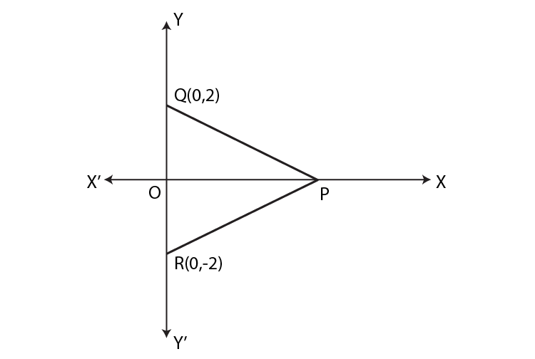

3) Factorise a) 8x3 + y3

b) 60x2 – 70x – 30

4) Factorise

(i) x2 + xy – x – y

5) The sum of two numbers is 50 . Write linear equation and find three solution to this equation

6) Without actually calculating the cubes, find the values of:

(i) (27)3 + (-17)3 + (-10)3

(ii) (-28)3 + (15)3 + (13)3

7) An exterior angle of a triangle is 105°, and its two interior opposite angles are equal. Find the measure of each of these equal angles.

8) AP and BQ are the bisectors of the two alternate interior angles formed by the intersection of a transversal t with parallel lines l and m (Fig. 6.11). Show that AP || BQ.

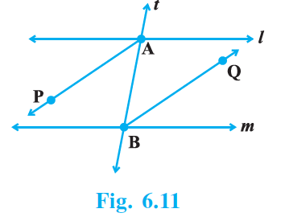

9) If two lines intersect, prove that the vertically opposite angles are equal.

10) In the given figure, which of the two lines are parallel and why?

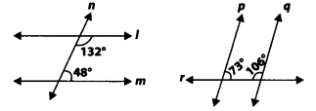

Art integrated activity

1.1.2 study of two dimensional shapes and three dimensional shapes

# MODERN PUBLIC SHOOL SECTOR-37

# FARIDABAD

## CLASS-IX SESSION-2024-25

## HOLIDAY HOME WORK

## SUBJECT-SCIENCE

Q1. Account for the following:

a- The temperature of the water remains constant during boiling.

b- Sand is solid.

c- Nail polish remover evaporates faster than water.

Q2. Sea water can be classified as a homogeneous as well as

heterogeneous mixture. Comment.

Q3. Sumit drives his car at a constant rate of 40 Kmh-1 for one hour and

then at a constant rate of 60 Kmh-1 for one more hour. Find his

average speed.

Q4. Draw velocity time graph for the following cases: -

a- When the object is in uniform motion.

b- When the object is thrown vertically upward.

Q5. Ice, water and steam are three states of substances and not

different substances justify.

Q6. If we sprinkle salt on cucumber slices after some times it releases

water. What mechanism is responsible for this?

Q7. Carry out the following osmoses experiment. Take four peeled

potato halves and scoop each one out to make potato cups. One of

these potato cups should be made from boiled potato. Put each

potato cup in a trough containing water. Now.

a- Keep cup A empty.

b- Put one tea spoon sugar in a cup B.

c- Put one tea spoon salt in a cup C.

d- Put one tea spoon sugar in the boiled potato cup D.

Keep these for two hours. Then observe the four potato cups and

answer the following: -

i) Explain why water gathers in the hollowed portion of B and C.

ii) Why is potato A necessary for this experiment?

iii) Explain why water does not gather in the hollowed-out portion of

A and D.

Q8. Art Integrated Project.: -

Study of visual resources of Manipur and

describing the natural resources available in Manipur and their

importance including the sketching of natural resources.

Q9. Make a poster on International Tiger Day on A3 size sheet, this

question is only for roll no. 1 to 10.

# Modern Public School Sector 37 Faridabad

## Summer Vacation Holiday homework

## Session 2024-25

## Subject- Social Science

## Class-9

## 

* **Instruction :**Holiday homework questions will be done in Economics notebook.

Holiday homework should be submitted by 3rd July 2024.

Q1- Explain the concept of “ Socialism”.

Q2- When and why did Slave trade flourish ?

Q3- “Our constituent assembly was a representative in character “.Discuss .

Q4- Who were prominent members of constituent Assembly ?

Q5- Discuss the main features of 12 th year plan in the field of Education .

Q6- Why are rivers important for country ‘s Economy ?

Q7- On the outline map of France label the following areas of Agrarian revolt in 1789 .

1. Paris
2. Nantes
3. Marseilles
4. Bordeaux

Q8-Human rights are women's rights, and women's rights are human rights."

* Topic : Women equality day

Prepare a collage or Poster describe about the past and present life of women ,their rights and duties . Role of women in Politics .

Q9- Creativity Corner :

* Prepare 3D model of Democracy (Roll no 1-10 )
* Prepare a working model showing greenhouse effects and climate change .(Rollno.11-20)
* Prepare 3D model showing fundamental rights and duties of citizens .(Roll no.21-30 )
* Prepare a model showing solar power irrigation system (31- above )

Q10- **Art integrated activity**- Prepare a PPT on Manipur showing about culture lifestyle ,festivals and the population census on mapping work .

# MODERN PUBLIC SCHOOL

## SUMMER HOLIDAY HOMEWORK (2024-2025)

## SUBJECT-IT

## CLASS-IX

Prepare any one of the following double sided wall hanging:-

A) Types of communication

B) 7C's communication

C) Verbal communication