**MODERN PUBLIC SCHOOL**

**HOLIDAY HOMEWORK**

**CLASS – VIII (MATHS)**

**Q,1 : In a quadrilateral ABCD, the measure of the three angles A, B and C of the quadrilateral is 110°, 70° and 80°, respectively. Find the measure of the fourth angle.**

**Q 2 : The opposite angles of a parallelogram are (3x + 5)° and (61 – x)°. Find the measure of four angles.**

**Q 3 : Solve each of the following equations**

**(i) x/2-10=1/2**

**ii) 2(x+2)+5(x+5)=4(x-8)+2(x-2)**

**Q 4 :** A bag contains 144 coloured balls represented by the following table. Draw a pie chart to show this information.  
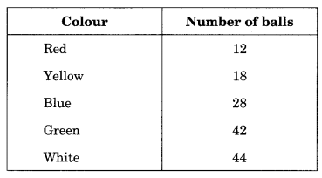

HuQ 5 : When a die is thrown, what is the probability of getting a prime number?

Q 6: **. If the product of any two rational numbers is 2 and one of them is 1/7, find the other?**

**Q 7 : Mention the commutativity, associative and distributive properties of rational numbers. Also, check a × b = b × a and a + b = b + a for a = ½ and b = ¾**

**Q 8 :** When the sum of the internal angles of a polygon is 10 right angles, then how many sides does it have?

Q 9 : **A bag contains 3 red balls, 5 black balls, and 4 white balls. A ball is drawn at random from the bag. What is the probability that the ball drawn is: (i) white? (ii) red? (iii) black? (iv) not red?**

**Q 10: Mention a rational number which has no reciprocal.**

**Q 11: Adjacent sides of a rectangle are in the ratio 5 : 12, if the perimeter of the rectangle is 34 cm, find the length of the diagonal.**

**Q 12: Find the measure of all four angles of a parallelogram whose consecutive angles are in the ratio 1 : 3.**

**Activity : write down the Properties of parallelogram in A3 size sheet**

**Note: Do holiday homework in fair notebook**