MODERN PUBLIC SCHOOL

Holiday Homework 2024-25

Class 4

English

Q1. From which novel has the story 'Tom Sawyer and Aunt Polly' been extracted? Name the writer also .

Q2. How did Aunt Polly punish Tom?

Q3. Fill in the blanks with suitable nouns as directed-

1. A ____ of lions was roaring at the deer. (collective noun)
2. Chandragupta ruled his ______ wisely. (abstract noun)
3. _____ is my best friend. (proper noun)
4. ____ were attacked by a cat. (common noun)

Q4. Write the opposite gender of the following nouns-

1. fox
2. bride
3. witch
4. stag
5. rooster

Q5. On an A4 size sheet, write a paragraph about your favourite freedom fighter. (Roll number 21-30)

*Revise all the work done in class.

*Do Q1-4 in English notebook.

मॉडर्न पब्लिक स्कूल

ग्रीष्मावकाश कार्य (2024)

कक्षा चौथी

विषय हिंदी

प्रश्न 1प्लास्टिक बैग और कपड़े के बैग के लाभ हानि चार पंक्तियों में लिखिए। आपके विचार में किसका प्रयोग उचित है? बताइए

प्रश्न 2 पाठ भिक्षा पात्र के आधार पर निम्मलिखित विशेषताएं किसके लिए प्रयोग की गई हैं?

भूखी धनी तुच्छ

प्यासे भाग्य का मारा

प्रश्न 3 पाठ 6 ईदगाह को पढ़कर दस कठिन शब्द लिखिए।

प्रश्न 4 कहानी की पुस्तक भेजने पर नाना जी को धन्यवाद पत्र।(याद कीजिए)

प्रश्न 5 दिए गए शब्दों के दो दो पर्यायवाची शब्द लिखिए।

भौंरा, यश, अमृत, सहायता, बंदर, समुद्र

प्रश्न 6 तुलसी का पौधा लगाकर प्रतिदिन पानी डालकर उगाइए।

रचनात्मक कार्य

* सूखी नीम की पत्तियों को A 3 साइज़ शीट पर चिपकाकर नीम के पेड़ के फ़ायदे लिखिए।
* (अनुक्रमांक 31से 39 के लिए) अपने पसंदीदा खेलों के चित्र चिपकाकर ‘राष्ट्रीय खेल दिवस’ पर एक पोस्टर तैयार कीजिए।
* Note - दिया गया समस्त कार्य हिंदी की कॉपी में करें।

Modern Public School

Holiday Homework

Class - IV

Subject – Math

Q1. Put commas and write the number names in

Indian system –

1. 9405236
2. 781965

Q2. Write in numerals –

1. Thirty lakh sixteen thousand ninety – nine.
2. Five lakh eight thousand one hundred

seventy – seven .

Q3. Solve :-

9650 + 3782 – 6899

Q4. Find the product :-

1. 57× 29
2. 306 × 84

Q5. Arrange the numbers 1 , 2 , 3 , 4 , 5 , 6 in each circle

such that sum of all the sides of the triangle is 9 . You

can use each number only once .

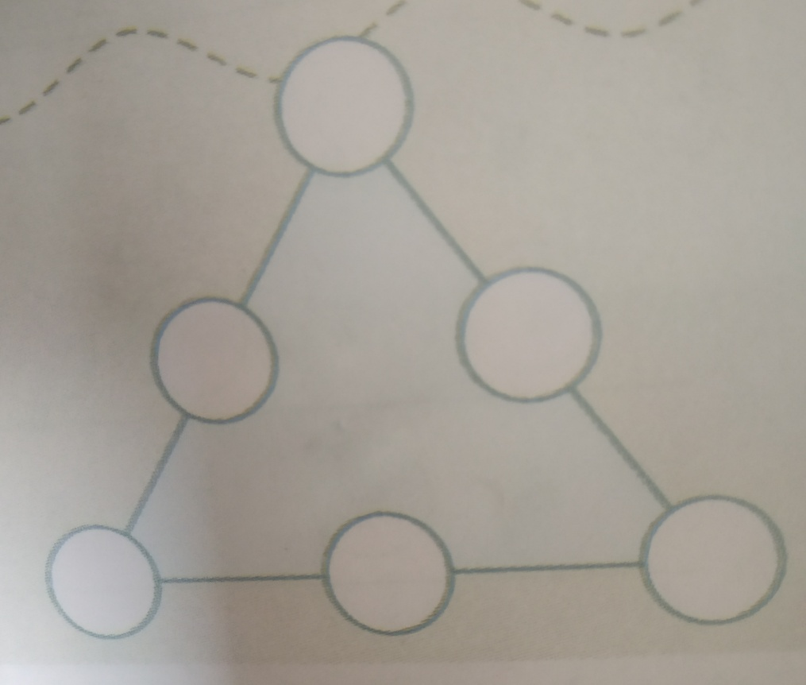

Note : Do these questions in your class register.

Complete till worksheet – 6

Learn Tables from 2 to 20.

Modern Public School

Holiday Homework (2024-25)

Class - IV Science

Q1 Answer the following:

a) The tip of a leaf ______

b) The stored food present in plants_____

c) A complete food_______

d) Body- building nutrient ______

e) Food preservatives___, _____

Q2 Fill in the blanks:

a) ______ keep our body warm in winter.

b) Mangrove trees have_____roots.

c) Plants make food using energy from the_____

d) The natural home of a plant or an animal is called______

Q3 What would happen if you do not eat a balanced diet?

Activity: Make a poster on World Population Day on A3 size sheet. (Roll No. 1 to 10)

* Read and revise L- 1, 2 and 5

* Do your holiday homework in science notebook.

**MODERN PUBLIC SCHOOL**

**HOLIDAY HOMEWORK (2024-2025)**

**CLASS - IV**

**SUBJECT - S.St.**

Q1 Write the capital of given states.

1. Bihar -
2. Uttarakhand -
3. Manipur-
4. Rajasthan -
5. Tamilnadu -

Q2 Which dam is built on river Satluj ?

Q3 Write the name of all neighbouring countries of India.

Q4 Name these:

1) Special kashmiri tea -

2) Landslides are common in this range -

3) Most populated country in the world-

4) The low hills of sand are called-

* Note: Holiday homework must be done in your S.St. notebook. Revise all the syllabus done in the class.

Activity Based Question(Roll No -11 to 20):

Make a poster on ‘Save Tiger Save Nature’(Use your ideas and creativity to Make your activity best)

**MODERN PUBLIC SCHOOL SECTOR-37, FBD**

**HOLIDAY HOMEWORK (2024-25) SUBJECT- DRAWING**

**CLASS – 4TH**

1. Make a pen holder by using waste material.
2. Draw and colour national flower on A4 size sheet.

MODERN PUBLIC SCHOOL

COMPUTER HHW

CLASS IV

Q. Prepare a double sided wall hanging on Different types of memory of a computer(Refer to page 8of your textbook)